BI
Mini Project
Cricket Players Performance System
(CPP)



Document Control
Table of Contents
Reference No:
Security Classification: | iGATE Internal
Issue Date:
Author(s): | Name |  | Title
Author(s): | Karthikeyan R |  | Dy Manager
Reviewer(s): | Name |  | Title
Issuer(s): | Name |  | Title
Issuer(s): | Karthikeyan R |  | Dy Manager
Issuer Signature(s):
Distribution: | Name |  | Title
Distribution: | iLEARN |  | All Designations in iLEARN
Document History: | Date | Revision | Change
Document History: | Mar 2014 | 0.01D | Initial draft
Document History: | Apr 2014 | 1.0 | Changes in Dimensional Model as well in Requirements
1 Introduction 4
1.1 Setup Checklist for Mini Project 4
1.2 Instructions 4
2 Problem Statement 5
2.1 Objective 5
2.2 Abstract of the project 5
2.3 Technology used: 5
3 Implementation in BI LOT 6
3.1 Summary of the functionality to be built: 6
3.2 Guidelines on the functionality to be built: 7
4 Evaluation and assessment parameters 11

Introduction

This document outlines a mini project for the BI LOT. The project is to develop Cricket Players Performance (CPP). This document contains the work flow of the system and gives guidelines on how to build the functionality gradually in each of the course modules of the BI LOT.

Setup Checklist for Mini Project
Minimum System Requirements
- Intel Pentium 90 or higher (P166 recommended)
- Microsoft Windows 95, 98, or NT 4.0, 2k, XP, Windows 2007.
- Memory: 32MB of RAM (64MB or more recommended)
- Internet Explorer 6.0 or higher
- Oracle 9i client and access to oracle 9i server
- Informatica 9.5.1
- BOXI R4

Instructions
- The code modules in the mini project should follow all the coding standards.
- Create a directory by your name in drive <drive>. In this directory, create a subdirectory MiniProject. Store your Project here.
- You can refer to your course material.
- You may also look up the help provided in the BI docs and documentation provided with Informatica and Business Objects.

Problem Statement

Objective
Development of a Cricket Players Performance System(CPP).

Abstract of the project
This project is aimed at developing Cricket Players Performance System (CPPS). The system will be used to check the performance of the cricketers of different countries in various types of international matches and to make decision support with the help of universe.

Technology used:
- Oracle 9i (Database)
- Informatica power center 9.5.1 (ETL Tool):-
- BusinessObjects XI Release 4

Implementation in BI LOT

Summary of the functionality to be built:
The participants need to develop the Cricket Players by building the functionality incrementally in each of the course modules of BI LOT.

Sr. No | Course | Duration | No. of Saturdays | Functionality to be built
Sr. No | Course | (in PDs) | No. of Saturdays | Functionality to be built
1. | Programming Foundation using Pseudo code | 5 | 2
3. | Oracle | 7 | 2
4. | Unix | 4 | 2
5. | Oracle Test | 1 | 2
6. | Informatica 9.5.1 | 6 | 1 | Perform ETL to generate the fact tables and Dimension tables.
6. | Informatica 9.5.1 Test | 1 | 1
7 | BOXI | 5 | 1 | Create a Universe in BO and create Reports
8 | BOXI Test | 1 | 1 | Create a Universe in BO and create Reports
9 | OBIEE 11g | 5 | 1 | Create a package in framework Manager and create reports in Report Studio and Analysis Studio
10 | OBIEE 11g Test | 1 | 1

Guidelines on the functionality to be built:

Project flow

Heterogeneous Sources i.e. operational data (Flat files)
EXTRACT
TRANSFORM
LOAD
Data warehouse (Oracle)
Reports Based On Universe
UNIVERSE
(Informatica)
(BO IDT)
(BO XI Rich WebI/WebI)

Schema Design:

The project follows the start schema approach. The Dimension tables are Country and Player. Fact Tables are Test_Fact , ODI_Fact , T20_Fact.
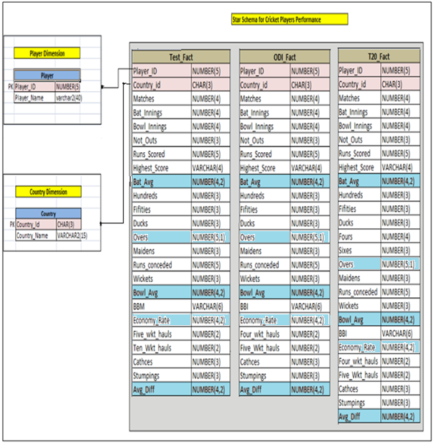

- Country:
This dimension contains information about the Country for which the player plays for.
This CSV file comprises of the following Fields:
- Country_Id
- Country Name
There are around countries and they are Australia (AUS), England (ENG), India (IND), New Zealand (NZ), Pakistan (PAK), South Africa (SA), Sri Lanka (SL), West Indies (WI)

- Player
This dimension contains Player details and the CSV file comprises of the following Fields:
- Player_ID
- Player_Name

The Player ID is a runnig sequence and unique number to be generated for all the players irrespective of the countries they are playing for.
The Player name can have the full name (First name + Last Name) of the player and in addition to this field, First Name, Middle Name and Last Name can also be added in this dimension table as per convenience.

The Facts are Test_Fact, ODI_Fact, T20_Fact

- Test_Fact
This is a Fact table that would contain the batting and bowling related information of each player and the country which he belongs to.
- Player_ID
- Country_id
- Matches
- Bat Innings
- Bowl Innings
- Not_Outs
- Fifities
- Hundreds
- Ducks
- Highest_Score
- Runs_Scored
- Bat_Avg
- Overs
- Maiden_Overs
- Runs_conceded
- Wickets
- Bowling_Avg
- BBM
- Economy_Rate
- Ten_wkt_Haul
- Five_wkt_Haul
- Cathces
- Stumpings

- ODI_Fact
This is a Fact table that would contain the batting and bowling related information of each player and the country which he belongs to.
- Player_ID
- Country_id
- Matches
- Bat Innings
- Bowl Innings
- Not_Outs
- Fifities
- Hundreds
- Ducks
- Highest_Score
- Runs_Scored
- Bat_Avg
- Overs
- Maiden_Overs
- Runs_conceded
- Wickets
- Bowling_Avg
- BBI
- Economy_Rate
- Four_wkt_Haul
- Five_wkt_Haul
- Cathces
- Stumpings

- T20_Fact
This is a Fact table that would contain the batting and bowling related information of each player and the country which he belongs to.
- Player_ID
- Country_id
- Matches
- Bat Innings
- Bowl Innings
- Not_Outs
- Fifities
- Hundreds
- Ducks
- Highest_Score
- Runs_Scored
- Bat_Avg
- Fours
- Sixes
- Overs
- Maiden_Overs
- Runs_conceded
- Wickets
- Bowling_Avg
- BBI
- Economy_Rate
- Four_wkt_Haul
- Five_wkt_Haul
- Cathces
- Stumpings

Note: The datatype/length for the Dimension/Fact table attribues can be changed as required. Additional fields can be added, if required.

Data Transformation for data warehouse:

- Load the Data into Dimension tables using the CSV files provided.
- Load the data into Fact table
  - Points to ponder.
    - Validate the foreign key values before loading.
    - Player_ID, Country_ID and Match_Category_Id are the Foreign Keys for this fact table and these three fields all-together form Primary key for this table.
    - The fact table should store the data pertaining to all the match categories (Teset matches, ODIs, T20) separately for each player.
    - The measures that do not have data in the CSV file should be given default value zero ‘0’ in the fact table while loading the data.
    - ‘*’ in HS (Highest) column in the Source – CSV files indicates that the batsman is Not Out (while scoring his highest score) and the same has to be loaded in the Highest_No_Ind field

Create a universe in Designer with the above 3 dimension table and the fact tables.

Sample Reports

- Top ten best Batting All-rounders (batting avg - desc)- All countries

- Top ten best Bowling All-rounders (balling avg - asc)- All countries

- Top ten best batsmen in terms of runs scored - All countries

- Top ten best batsmen in terms of Average - All countries

- Top three best batsmen in terms of runs scored – Countrywise

- Top ten best Ballers in terms of average – All Countries

- Top ten best Ballers in terms of Wickets – All Countries

- Top three best ballers in terms of wickets – Countrywise

- Bottom Five Batsmen(Consider lowest Batting Average) – All countries

- Botton Five Ballers(Consider Highest Bowling Average) – All Countries

- Best Player in Terms of Highest Runs – All Countries and CountryWise

- Best Player in terms of Most Runs – All Countries and CountryWise

- Best Player in terms of Most wickets – All Countries and CountryWise

- Most Innings - All Countries and CountryWise

- Maximum Number of Hundreds in Test, ODI and t20 format – All Countries and CountryWise

- Maximum number of 50’s in Test, ODI and t20 format – All Countries and CountryWise

- Maximum number of Not Out’s in Test. – All Countries and CountryWise

Referred to the shared source files.

Evaluation and assessment parameters
This mini project will be done in groups of five or six. Each group will identify a Team Lead who will decide which team member will code for which functionality. This project shall be evaluated in two phases. Evaluation will be done using online presentation mode, where each group will present their respective modules.

Evaluation Parameters (100 Marks)
- ETL Scripts and DW design (25)
The extent to which the ETL was performed, the transformations used
Deliverables in terms of time lines
- Universe Design (35)
The way the universe was designed with appropriate classes and objects, conditions created
- Deliverables(Reports) (40)
Presentation of reports.

